Semester | S.E. Semester IV
Subject | Operating System

Student Name | Sukumar Suhas Sawant
Roll Number | 24102B0049

Experiment  Number | 02
Experiment Title | Write programs to demonstrate the concept of non-pre-emptive scheduling algorithms (FCFS, SJF, Non-pre-emptive Priority)
Resources /  Required | Hardware: I/O Devices (Monitor, Keyboard, Mouse, CPU, RAM, etc.)  Software: C/Java
Objectives  (Skill Set /  Knowledge  Tested /  Imparted) | Learning about the different non-pre-emptive scheduling algorithm. Implementing programs to demonstrate working of FCFS, SJF and Priority Scheduling Algorithms.
Theory | In computing, scheduling is the method by which work is assigned to resources that complete the work. The work may be virtual computation elements such as threads or processes which are in turn scheduled onto hardware resources such as processors.  A scheduler is what carries out the scheduling activity. Schedulers are often implemented so they keep all computer resources busy (as in load balancing), allow multiple users to share system resources effectively, or to achieve a target quality of service. Scheduling is fundamental to computation itself, and an intrinsic part of the execution model of a computer system; the concept of scheduling makes it possible to have computer multitasking with a single central processing unit (CPU).  Non Preemptive Scheduling:  When any process is in execution,and any other high priority process enters the system, the control is not passed to the new process irrespective of the priority. This type of scheduling algorithm is known as Non-Preemptive Scheduling Algorithm.  First Come First Serve (FCFS): In this algorithm, the processes are executed in the order that they arrive. There is no change in the order of the processes. Control is passed to the next process only after the execution of the previous process is completed.  Shortest Job First(SJF): is a scheduling policy that selects the waiting process with the smallest execution time to execute next. SJF can be used in specialized environments where accurate estimates of running time are available.
Program | FCFS  #include <bits/stdc++.h>  #include <ext/pb_ds/assoc_container.hpp>  using namespace std;  using namespace __gnu_pbds;  #define pb push_back  using ll = long long;  using vi = vector<int>;  using vii = vector<vector<int>>;  using vll = vector<ll>;  using pii = pair<int,int>;  using pll = pair<ll,ll>;  using vpi = vector<pair<int,int>>;  using vpl = vector<pair<ll,ll>>;  #define max_pq priority_queue<int>  #define min_pq priority_queue<int, vector<int>, greater<int>>  #define pyes cout<<"YES"<<endl  #define pno cout<<"NO"<<endl  #define rt return  #define endl '\n'  #define int ll  #define rep(i, a, b) for(int i = a; i < (b); ++i)  #define all(x) begin(x), end(x)  #define tc cerr << "Time: " << (1.0 * clock() / CLOCKS_PER_SEC) << "s\n";  #define MOD 100000000007  #define MAX_SIZE 200001  #define ps(x, y) fixed << setprecision(y) << x  ll INF = 1e18;  void solve();  signed main(){  ios_base::sync_with_stdio(false);  cin.tie(NULL);  int t=1;  cin>>t;  while(t--){  solve();  }  }  typedef struct Process{  ll id=0;  ll at=0;  ll bt=0;  ll ct=0;  ll tat=0;  ll wt=0;  }P;  void solve(){  int n; cin>>n;  vector<P>p(n);  cout<<"Enter The arrival Time and the burst time "<<endl;  for(int i =1;i<=n;++i) p[i-1].id = i;  for(int i =0;i<n;++i) cin>>p[i].at>>p[i].bt;  auto cmp = [&](auto &a,auto &b){  if(a.at == b.at){  return a.id <b.id ;  }  return a.at<b.at;  };  sort(all(p),cmp);  int current_time = 0;  for(int i =0;i<n;++i){  if(p[i].at>current_time) current_time = p[i].at;  // if 0->5 first pid runs and then there is GAP  current_time +=p[i].bt;  p[i].ct = current_time;  p[i].tat = p[i].ct - p[i].at;// tat = ct - at  p[i].wt = -p[i].bt + p[i].tat ;// tat = wt + bt  }  cout << "PID AT BT CT TAT WT\n";  for (auto &x : p) {  cout << x.id << " "  << x.at << " "  << x.bt << " "  << x.ct << " "  << x.tat << " "  << x.wt << "\n";  }  }
Output | 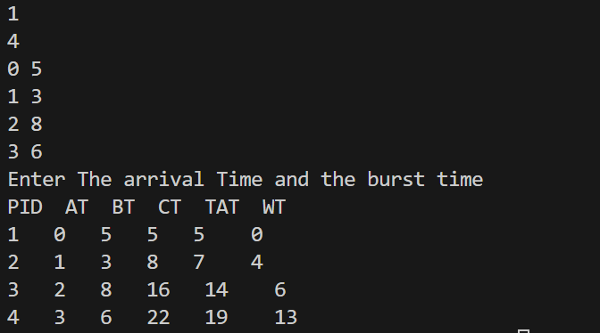
Program | SJF  #include <bits/stdc++.h>  #include <ext/pb_ds/assoc_container.hpp>  using namespace std;  using namespace __gnu_pbds;  #define pb push_back  using ll = long long;  using vi = vector<int>;  using vii = vector<vector<int>>;  using vll = vector<ll>;  using pii = pair<int,int>;  using pll = pair<ll,ll>;  using vpi = vector<pair<int,int>>;  using vpl = vector<pair<ll,ll>>;  #define max_pq priority_queue<int>  #define min_pq priority_queue<pii, vector<pii>, greater<pii>>  #define pyes cout<<"YES"<<endl  #define pno cout<<"NO"<<endl  #define rt return  #define endl '\n'  #define int ll  #define rep(i, a, b) for(int i = a; i < (b); ++i)  #define all(x) begin(x), end(x)  #define tc cerr << "Time: " << (1.0 * clock() / CLOCKS_PER_SEC) << "s\n";  #define MOD 100000000007  #define MAX_SIZE 200001  #define ps(x, y) fixed << setprecision(y) << x  ll INF = 1e18;  void solve();  signed main(){  ios_base::sync_with_stdio(false);  cin.tie(NULL);  int t=1;  cin>>t;  while(t--){  solve();  }  }  typedef struct Process{  ll id=0;  ll at=0;  ll bt=0;  ll ct=0;  ll tat=0;  ll wt=0;  }P;  void solve(){  int n; cin>>n;  vector<P>p(n);  cout<<"Enter The arrival Time and the burst time "<<endl;  for(int i =1;i<=n;++i) p[i-1].id = i;  for(int i =0;i<n;++i) cin>>p[i].at>>p[i].bt;  auto cmp = [&](auto &a,auto &b){  if(a.at == b.at){  return a.id <b.id ;  }  return a.at<b.at;  };  auto cmp1 = [&](auto &a,auto &b){  return a.id<b.id;  };  sort(all(p),cmp);  min_pq pq;  vector<P> ans;  int current_time = 0;  int i =0;  while(i<n || !pq.empty()){  while(i<n && p[i].at <=current_time){  pq.push({p[i].bt,i});  i++;  }  if(pq.empty()){  current_time = p[i].at; continue;  }  auto [bt,idx] = pq.top();  pq.pop();  current_time+= bt;  p[idx].ct = current_time;  p[idx].tat = p[idx].ct - p[idx].at;  p[idx].wt = p[idx].tat-p[idx].bt;  ans.push_back(p[idx]);  }  sort(all(ans),cmp1);  cout << "PID AT BT CT TAT WT\n";  for (auto &x : ans) {  cout << x.id << " "  << x.at << " "  << x.bt << " "  << x.ct << " "  << x.tat << " "  << x.wt << "\n";  }  }
Output | 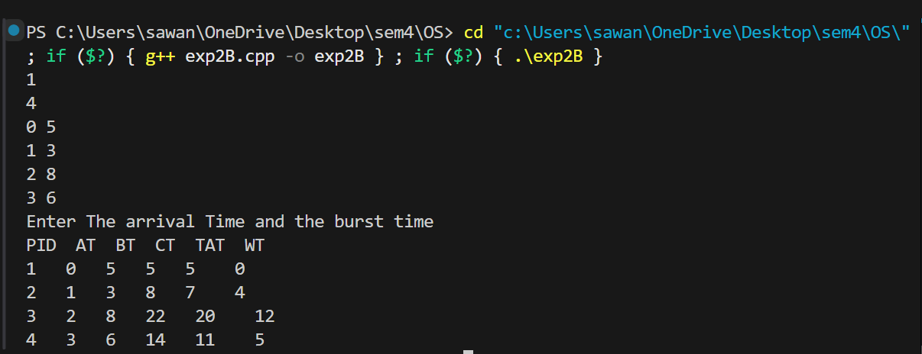
Conclusion | From this experiment, I learned how to simulate FCFS, and SJF. I understood how FCFS depends on arrival time, the ones with less arrival time, gets served first, while in SJF, it depends on minimum burst time, but the process to be chosen must’ve arrived by the current time.

